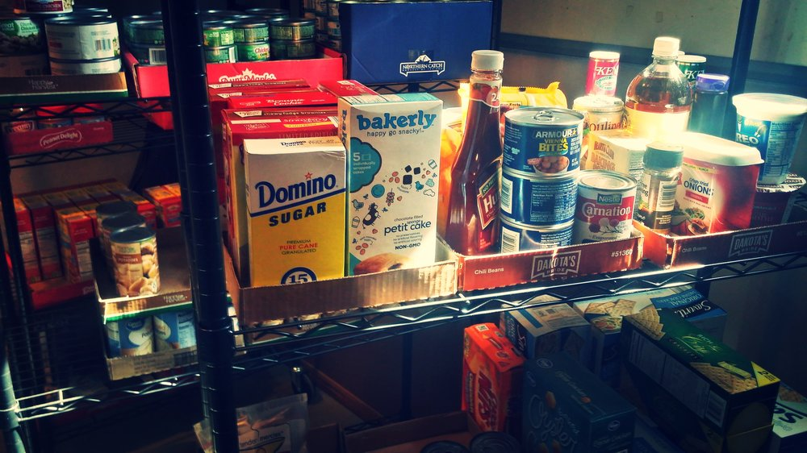

WHITEROSE FOOD PANTRY

location: 505 S Main street, bellevue illinois, 61604

available For the Norwood School District in Peoria County

- 2nd and 4th saturdays every month
  - 4-5 pm
- Registration required, bring:
  - photo id
  - 2 forms of mail including address
  - 2 boxes / laundry baskets
- questions call:
  - coordinator judy wight: 309-323-1208 after 5pm
  - pastor david gruber @ church office: 309-697-4554
https://www.wrf.church/

Home

Sunday gatherings:
9:30am foundations class
10:30am worship service
505 S Main Street, Bellevue IL, 61604

